**Figure 1. Model of MBOAT members topology.**

**SSP**

**lumen of secretory pathway**

**membrane**

**cytoplasm**

**N**

**C**

**Hhat/Porc/GOAT**

**Acylated secreted signaling protein**

**PalCoA**

**Transmembrane domain**

**Conserved His**

**PalCoA**

**SSP**

### Figure 2. Post-translational modifications of Hh

**45 kDa precursor**

**Signal peptide**

## CF…

**CGP… …G**

**PalmitoylCoA**



**Signal peptide**

# Hhat

pal



pal

**CGP… …G**

**CF…**



**Cholesterol**

**19 kDa Hh-Np**

**25 kDa Hh-C**

## CF…



**CGP… …G**

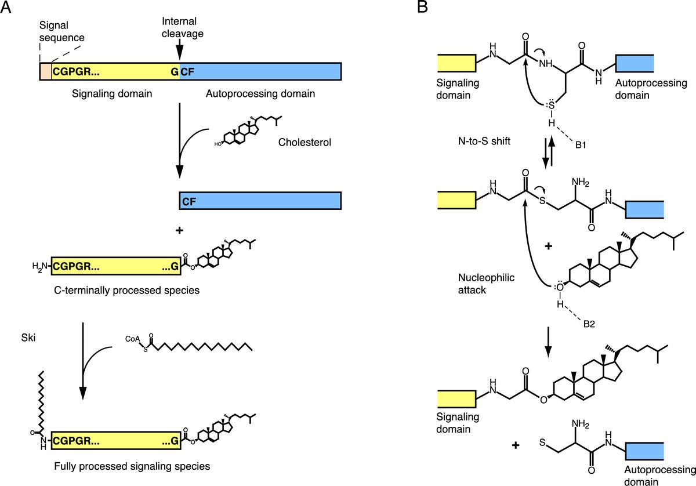

**Figure 3. Model of active soluble Hh/Shh multimeric complex transport (based on Chen et al., 2004).**

**SMO**

## PTC

**SMO**

**PTC**

**Activated Gli/Ci**

**Target genes activation**

**Extracellular Matrix**

**Target genes activation**

**Hh-receiving cell**

**Hh-receiving cell**

#### HSPGs

**Hh-Np**

**Hh-FL**

## Hh-producing cell

**Hh-producing cell**